# CRUD BLOG WEBSITE APPLICATION

A PROJECT REPORT

*Submitted by*

**Tanya Yadav [Reg No: RA2211031010112]**

**Jiya Gayawer [Reg No: RA2211031010129]**

**Anoushka Shrivastava [Reg No: RA2211031010135]**

*Under the Guidance of*

## Dr. Dayana D.S.

Assistant Professor, Department of Networking and Communications

*in partial fulfillment of the requirements for the degree of*

**BACHELOR OF TECHNOLOGY**

in

**COMPUTER SCIENCE AND ENGINEERING WITH SPECIALIZATION IN INFORMATION TECHNOLOGY**



**DEPARTMENT OF NETWORKING AND COMMUNICATIONS**

**COLLEGE OF ENGINEERING AND TECHNOLOGY**

**SRM INSTITUTE OF SCIENCE AND TECHNOLOGY**

**KATTANKULATHUR– 603 203**

**MAY 2024**



# SRM INSTITUTE OF SCIENCE AND TECHNOLOGY

# KATTANKULATHUR–603 203

**BONAFIDE CERTIFICATE**

**Register no. RA2211031010112, RA2211031010129, RA2211031010135** Certified to be the bonafide work done by **Tanya Yadav, Jiya Gayawer, Anoushka Shrivastava** of II year/IV sem B.Tech Degree Course in the Project Course – **21CSC205P Database Management Systems** in **SRM INSTITUTE OF SCIENCE AND TECHNOLOGY**, Kattankulathur for the academic year 2023-2024.

**Date:**

|  |  |
| --- | --- |
| **Faculty in Charge**  Dr. Dayana DS  Assistant Professor  Department of Networking  and Communications  SRMSIT -KTR | **HEAD OF THE DEPARTMENT**  Dr. Annapurani Panaiyappan  Professor and Head  Department of Networking  and Communications  SRMIST - KTR |

**ABSTRACT**

In today's digital landscape, the demand for versatile online platforms for content consumption and community engagement is more pronounced than ever. This abstract presents the design and development of a multi-functional blog website with integrated live cryptocurrency updates, catering to the diverse needs and interests of modern internet users.

The proposed blog website offers a user-friendly interface designed for seamless navigation and optimal readability across various devices. Users can explore a vast array of blogs spanning different topics, with options to filter and search for specific content based on categories and subcategories. Furthermore, a user-friendly submission system allows aspiring writers to contribute their own content via email, fostering a collaborative and inclusive environment.

One of the distinguishing features of the website is its integration of real-time cryptocurrency updates, providing users with valuable insights into market trends, prices, and news. This dedicated section serves as a valuable resource for cryptocurrency enthusiasts and investors seeking up-to-date information and analysis.

To facilitate constructive discussions and maintain a respectful community atmosphere, all user comments on blog posts undergo admin approval before being made visible to others. This comment moderation system ensures that the platform remains conducive to meaningful interactions and exchanges of ideas.

Behind the scenes, an intuitive admin panel empowers site administrators with comprehensive control over content management and website functionality. Admins can add, edit, and delete posts, manage categories and subcategories, approve, or reject user-submitted content, and perform other administrative tasks efficiently.

In summary, the proposed blog website addresses the evolving needs of online audiences by offering a diverse range of content, real-time cryptocurrency updates, and robust community moderation features. By combining these elements, the website aims to create an engaging and informative digital space where users can explore, contribute, and connect with like-minded individuals.

**PROBLEM STATEMENT**

Despite the increasing demand for versatile online platforms that cater to diverse interests and facilitate community engagement, existing blog websites often lack features that fully address the evolving needs of modern internet users. Many platforms struggle to provide real-time updates on trending topics, particularly in niche areas such as cryptocurrency, while simultaneously fostering a respectful and engaging community atmosphere. Additionally, content management systems may lack intuitive interfaces, making it challenging for site administrators to efficiently manage and moderate user-generated content.

These limitations create a gap in the digital landscape, leaving users without a comprehensive solution that seamlessly integrates diverse content, real-time updates, and robust community moderation features. As a result, there is a need for a multi-functional blog website that offers a user-friendly interface, integrates live cryptocurrency updates, and empowers administrators with comprehensive control over content management and community moderation.

## TABLE OF CONTENTS

|  |  |  |
| --- | --- | --- |
| **Chapter No** | **Chapter Name** | **Page No** |
| **1.** | Problem understanding, Identification of Entity and Relationships, Construction of DB using ER Model for the project | 1-4 |
| **2.** | Design of Relational Schemas, Creation of Database Tables for the project. | 5-13 |
| **3.** | Complex queries based on the concepts of constraints, sets, joins, views, Triggers and Cursors. | 14-22 |
| **4.** | Analyzing the pitfalls, identifying the dependencies, and applying normalizations | 23-25 |
| **5.** | Implementation of concurrency control and recovery mechanisms | **26-28** |
| **6.** | Code for the project | **29-37** |
| **7.** | Result and Discussion (Screen shots of the implementation with front end. | 38-43 |
| **8.** | Attach the Real Time project certificate / Online course certificate | 44-45 |

### CHAPTER 1

**Problem Understanding**

In the digital age, content consumption has become a daily habit for millions worldwide. However, there remains a need for a versatile blog platform that not only caters to diverse interests but also integrates real-time information such as cryptocurrency updates. This project aims to develop a comprehensive blog website that encompasses several key features:

**User-Friendly Interface:** The website should offer a seamless browsing experience, allowing users to navigate through different sections effortlessly. It should prioritize readability and accessibility across various devices.

**Content Consumption:** Users should be able to browse and read a wide range of blogs covering diverse topics. Additionally, the website should provide options for users to search for specific content, filter posts by categories and subcategories, and save articles for future reference.

**Interactive Writing Experience:** Enabling users to contribute their own content is essential. To achieve this, a feature allowing users to submit blog posts via email to the admin should be implemented. This ensures an inclusive platform where aspiring writers can share their thoughts and insights.

**Real-time Cryptocurrency Updates:** Given the growing interest in cryptocurrency, integrating live updates on cryptocurrency prices, market trends, and news is paramount. Users should have access to this information in a dedicated section of the website, providing valuable insights for investors and enthusiasts alike.

**Comment Moderation:** To maintain a healthy and constructive discourse, all user comments on blog posts should undergo admin approval before becoming visible to other users. This ensures a safe and respectful environment for discussions.

**Admin Panel:** The admin panel should provide comprehensive control over the website's content and functionality. Admins should be able to add, edit, and delete posts, manage categories and subcategories, approve, or reject user-submitted posts and comments, and perform other administrative tasks efficiently.

By addressing these requirements, the proposed blog website aims to cater to the diverse interests of users while offering valuable insights into the world of cryptocurrency. It strives to foster a community where knowledge sharing and engagement thrive, enhancing the digital experience for all users.

**Identification of Entity and Relationships**

Entities:

1. User (userID, fname, lname, password, email, bio, username)
2. Tag (tagID, name)
3. Category (categoryID, name)
4. Admin (adminID, fname, lname, email, password, username)
5. Follow (followID, followerID, followedID)
6. Post (postID, userID, content, date)
7. Message (messageID, userID, content)
8. Report (reportID, userID, reason)
9. Like (likeID, userID, postID)
10. Dislike (dislikeID, userID, postID)
11. Settings (settingID, userID, ...)
12. ActivityLog (activitylogID, userID, type, date-time)
13. Notification (notifID, userID, content)
14. Subscription (subID, userID, subscreated)
15. Comments (commentID, postID, date, userID, content)

**Relationships:**

1. User: One-to-Many (Post, Message, Report, Like, Dislike, ActivityLog, Notification, Subscription, Comments); One-to-One (Settings, Chatbot)
2. Tag: Many-to-Many (Post)
3. Category: One-to-Many (Post)
4. Admin: One-to-Many (Report)
5. Follow: Many-to-Many (User - self-referencing)
6. Post: Many-to-One (User); Many-to-Many (Tag)
7. Message: Many-to-One (User)
8. Report: Many-to-One (User, Admin)
9. Like: Many-to-One (User, Post)
10. Dislike: Many-to-One (User, Post)
11. Settings: One-to-One (User)
12. ActivityLog: Many-to-One (User)
13. Notification: Many-to-One (User)
14. Subscription: Many-to-One (User)
15. Comments: Many-to-One (User, Post)

**Construction of DB using ER Model for the project**

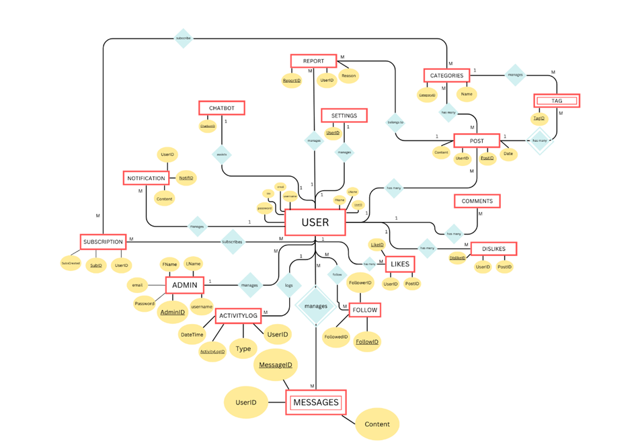

**Fig. 1.1** ER- Diagram

**CHAPTER 2**

**Design of Relational Schemas**

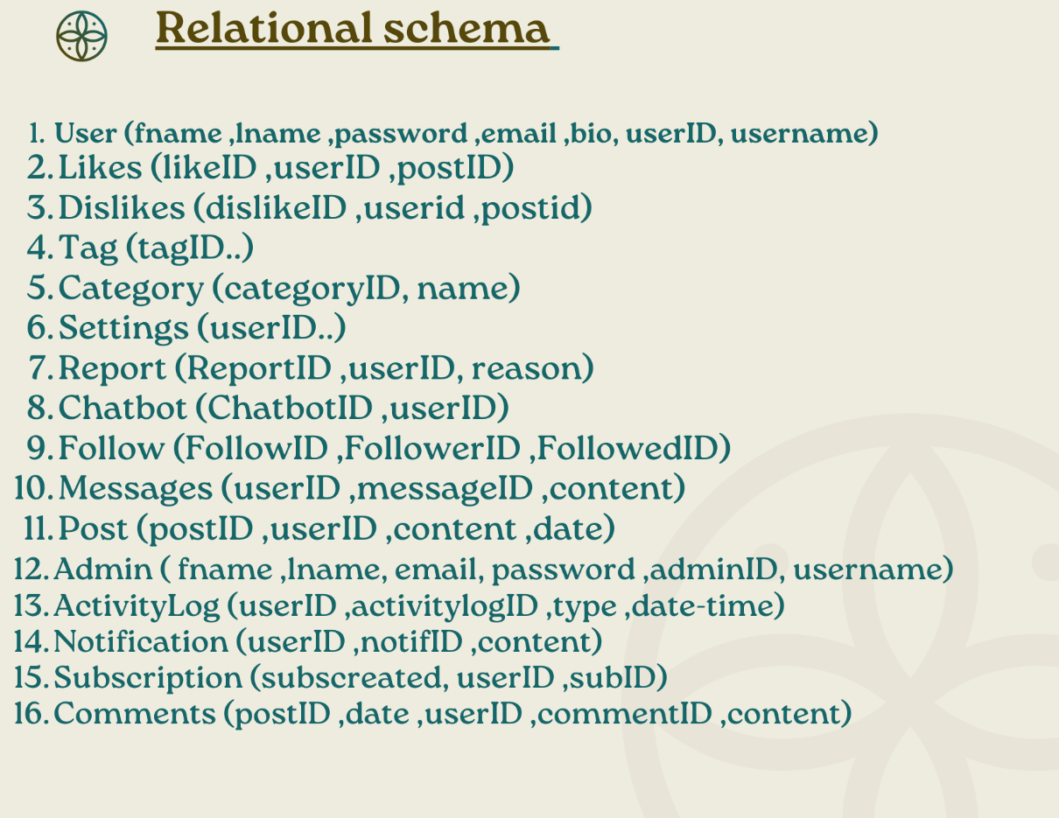

**Fig 2.1** Relational Schema

**Creation of Database Tables for the project**

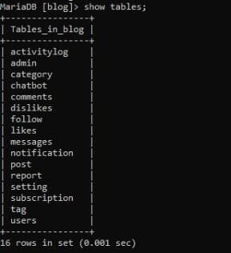

**Fig 2.1** Tables Overview

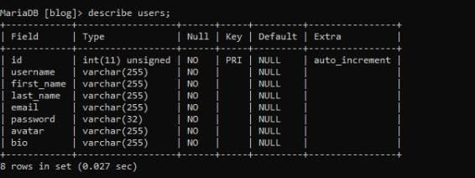

**Fig 2.2** User Table Description

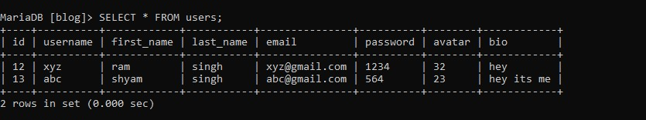

**Fig 2.3** User table

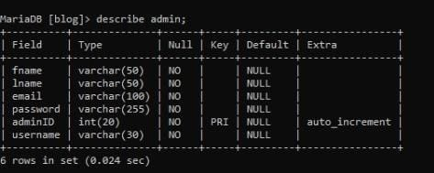

**Fig 2.4** Admin Table Description

**Fig 2.5** Admin Table

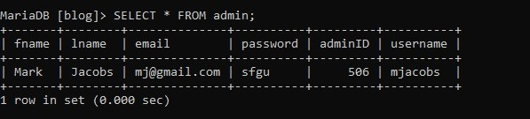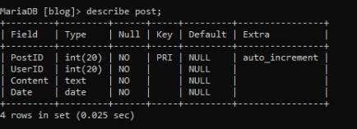

**Fig 2.6** Post Table Description

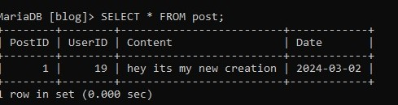

**Fig 2.7** Post Table

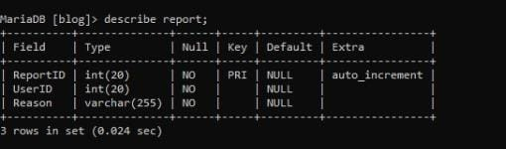

**Fig 2.8** Report Table Description

**Fig 2.9** Report Table

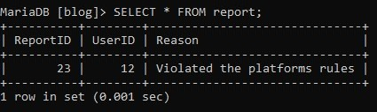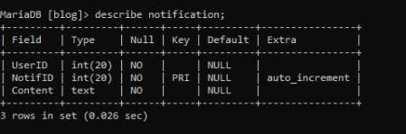

**Fig 2.10** Notification Table Description

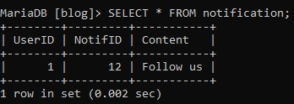

**Fig 2.11** Notification Table

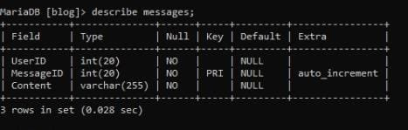

**Fig 2.12** Messages Table Description

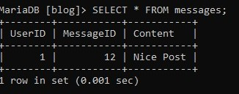

**Fig 2.13** Messages Table

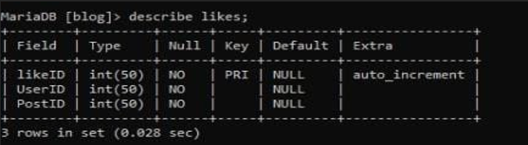

**Fig 2.14** Likes Table Description

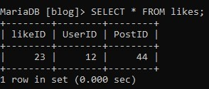

**Fig 2.15** Likes Table

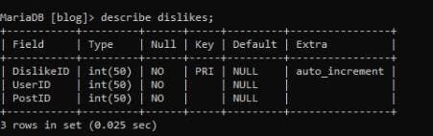

**Fig 2.16** Dislikes Table Description

**Fig 2.17** Dislikes Table

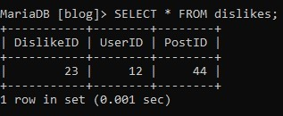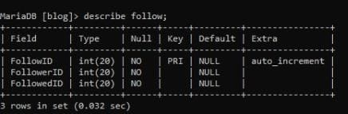

**Fig 2.18** Follow Table Description

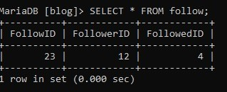

**Fig 2.19** Follow Table

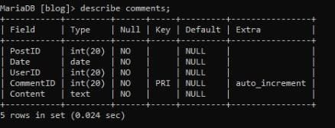

**Fig 2.20** Comments Table Description

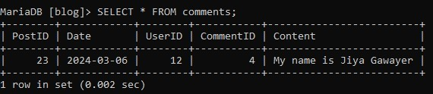

**Fig 2.21** Comments Table

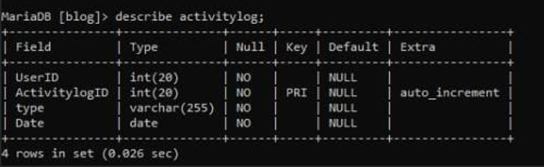

**Fig 2.22** Activitylog Table Description

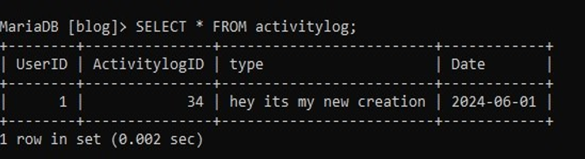

**Fig 2.23** Activitylog Table

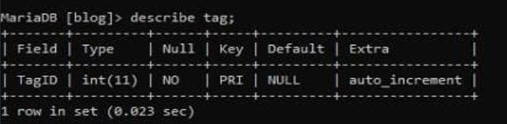

**Fig 2.24** Tag Table Description

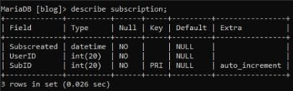

**Fig 2.25** Subscription Table Description

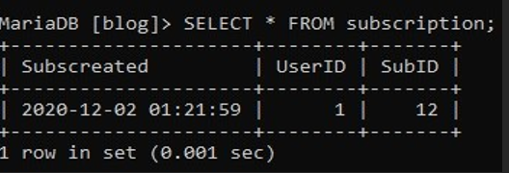

**Fig 2.26** Subscription Table

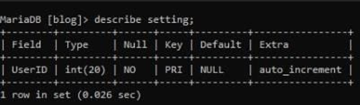

**Fig 2.27** Setting Table Description

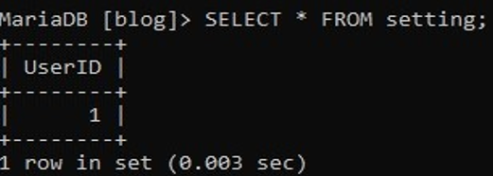

**Fig 2.28** Setting Table

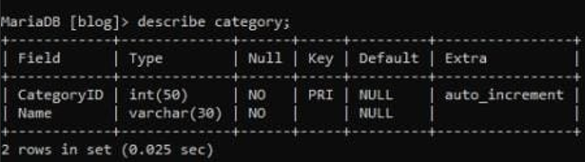

**Fig 2.29** Category Table Description

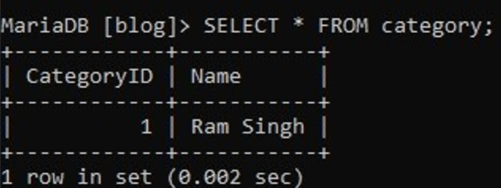

**Fig 2.30** Category Table

### CHAPTER 3

**Complex queries based on the concepts of:**

**Constraints**

Constraints in database tables enforce rules and restrictions on the data stored within those tables, ensuring data integrity and consistency.

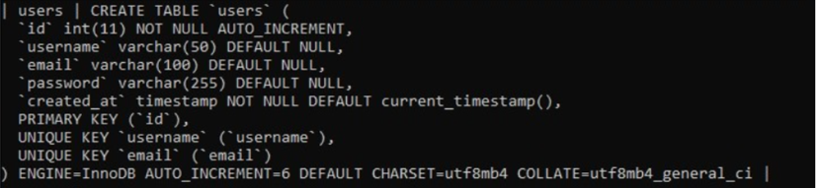

**Fig 3.1** User Table Constraints

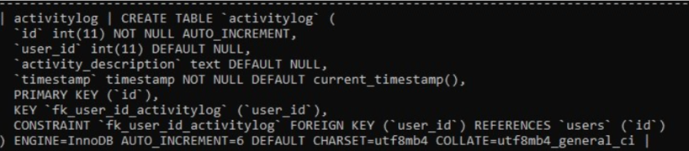

**Fig 3.2** Activitylog Table Constraints

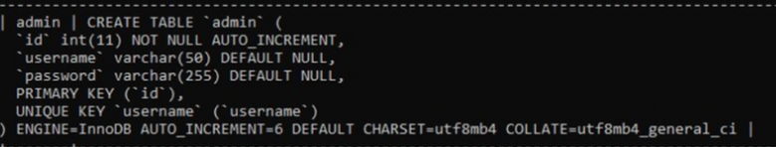

**Fig 3.3** Admin Table Constraints

**Fig 3.4** Category Table Constraints

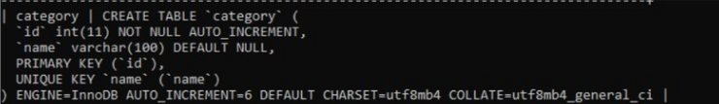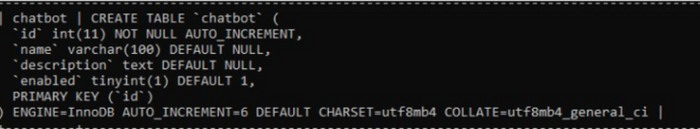

**Fig 3.5** Chatbot Table Constraints

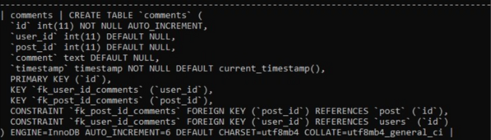

**Fig 3.6** Comments Table Constraints

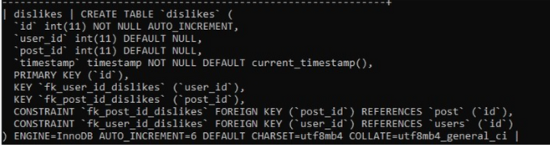

**Fig 3.7** Dislikes Table Constraints

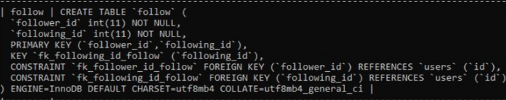

**Fig 3.8** Follow Table Constraints

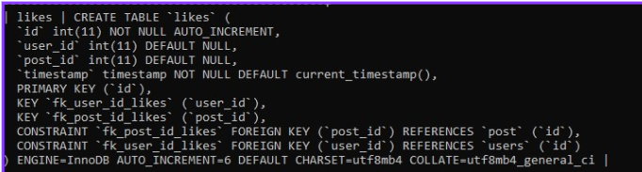

**Fig 3.9** Likes Table Constraints

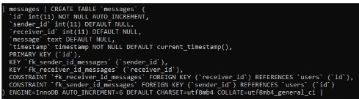

**Fig 3.10** Messages Table Constraints

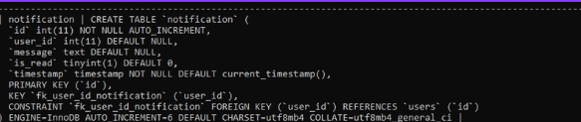

**Fig 3.11** Notification Table Constraints

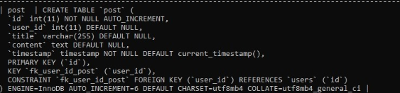

**Fig 3.12** Post Table Constraints

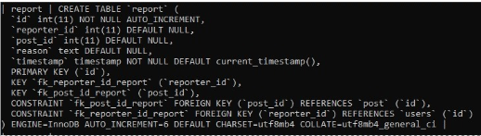

**Fig 3.13** Report Table Constraints

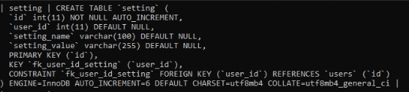

**Fig 3.14** Setting Table Constraints

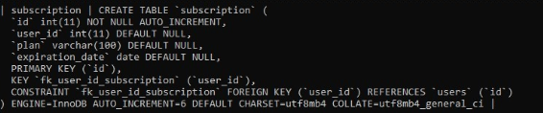

**Fig 3.15** Subscription Table Constraints

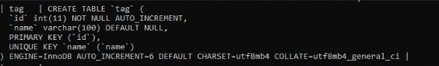

**Fig 3.16** Tag Table Constraints

**Joins**

**Inner Join:**

* **Users and Posts to Retrieve Usernames and Post Titles:** This query retrieves usernames of users who have posted articles along with the titles of their posts.

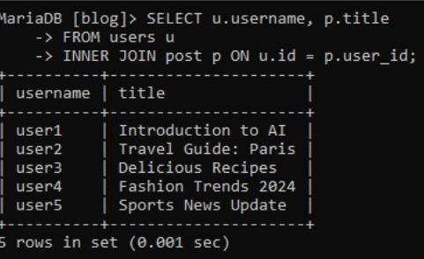

**Fig 3.17** Inner Join

**Outer Right Join:**

* **Right Join Comments and Posts to Retrieve Comment Content and Post Titles:** This query retrieves the content of comments made on posts along with the titles of the posts they were made on. It includes all posts even if there are no comments on them.

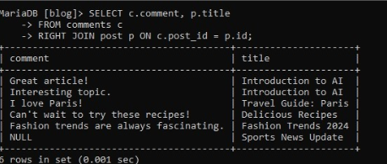

**Fig 3.18** Right Join

**Outer Left Join:**

* Retrieve all users and their associated posts, including users who have not made any posts.

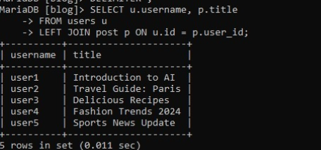

**Fig 3.19** Left Join

**Self-Join:**

* Retrieve users who follow each other.

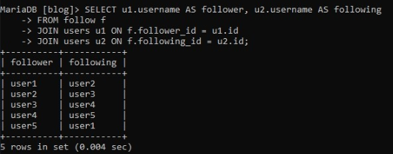

**Fig 3.20** Self Join

**Cross Join:**

* Retrieve all combinations of users and categories.

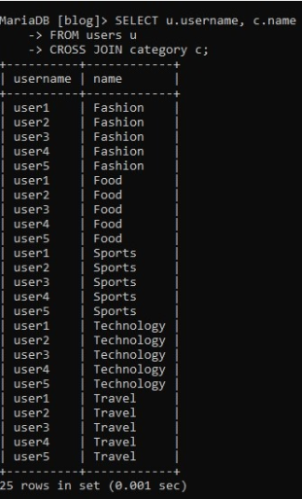

**Fig 3.21** Cross Join

**Views**

Views will be created to store predefined SQL queries, providing a simplified way to access frequently used data or complex query results.

* **User Activity View (user_activity_view):**

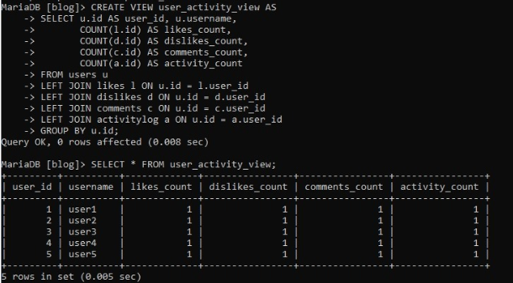

**Fig 3.22** user_activity_view

* **Post Comments View (post_comments_view):** This view combines information from the post and comments tables to provide details about each post along with the number of comments it has received.

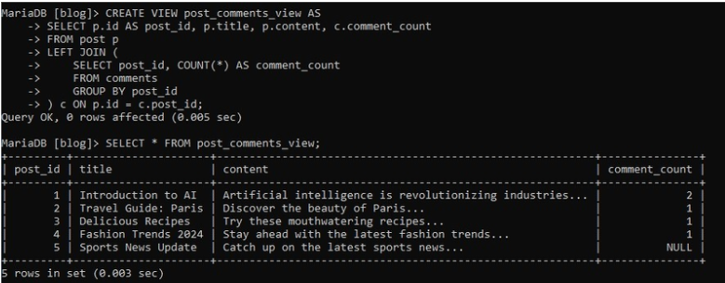

**Fig 3.23** post_comments_view

**Triggers**

**Trigger to Log User Activity (activitylog_trigger):** This trigger will automatically insert a record into the activitylog table whenever a user logs in.

This trigger is set to execute after an insertion into the users table (AFTER INSERT ON users). For each new row inserted (FOR EACH ROW), it inserts a corresponding record into the activitylog table. The inserted record contains the user_id of the newly inserted user and a descriptive message indicating the user's login activity.

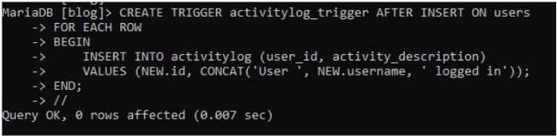

**Fig 3.24** activitylog_trigger

**Trigger to Update Post Count in Category Table (post_count_trigger):** This trigger will automatically update the post count in the category table whenever a new post is added or deleted.

This trigger is set to execute after an insertion into the post table (AFTER INSERT ON post). For each new row inserted (FOR EACH ROW), it updates the post_count column in the category table. The updated count is obtained by counting the number of posts associated with each category.

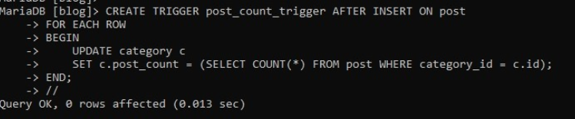

**Fig 3.25** post_count_trigger

**Cursors**

Cursors: Cursors will be used to iterate through a result set returned by a SELECT query, enabling us to perform operations on each row individually.

**Cursor to fetch and display user information:**

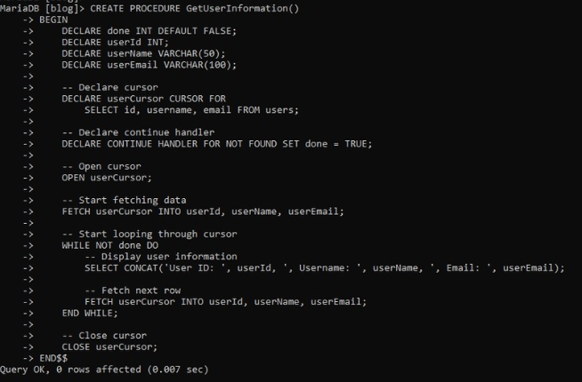

**Fig 3.26** Cursor implementation

**Cursor to calculate total likes for each post:**

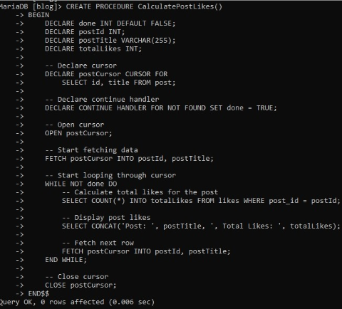

**Fig 3.27** Cursor implementation

**CHAPTER 4**

**Analyzing The Pitfalls**

Redundancy: Storing the same data in multiple places can lead to inconsistencies and inefficiencies.

Inconsistency: Data inconsistencies can occur when distinct parts of the database hold different versions of the same data.

Inefficiency: Poor database design can result in slower query performance and increased storage requirements.

Complexity: A complex database schema can be difficult to understand and maintain, leading to errors and inefficiencies

1. **activitylog Table:**

Pitfalls: Data Inconsistency

Example: An activity log entry records a user action, but the associated user ID does not exist in the users table, leading to inconsistency in data.

2. **admin Table:**

Pitfalls: Security

Example: Storing passwords in plain text instead of hashed format in the admin table poses a security risk, as anyone with database access can view sensitive information.

3. **category Table:**

Pitfalls: Data Inconsistency

Example: Duplicate category names exist in the category table, leading to ambiguity in categorizing posts.

5. **comments Table:**

Pitfalls: Data Inconsistency

Example: A comment in the comments table is associated with a post that no longer exists, resulting in orphaned data and potential errors when accessing comments.

6. **dislikes Table:**

Pitfalls: Data Inconsistency

Example: A dislike entry in the dislikes table is linked to a user who has been deleted, resulting in a referential integrity violation.

7. **follow Table:**

Pitfalls: Data Integrity

Example: A follow relationship in the follow table refers to a user ID that was mistakenly assigned to a different user, leading to incorrect follower/following associations.

8. **likes Table:**

Pitfalls: Data Inconsistency

Example: A like entry in the likes table is associated with a post that was deleted, causing inconsistencies and potential errors when displaying post likes.

9. **messages Table:**

Pitfalls: Data Integrity

Example: A message in the messages table is sent from a user ID that no longer exists, making it impossible for the recipient to view or respond to the message.

**Functional Dependencies**

1. Activity Log (activitylog):

id->user_id,activity_description, timestamp

user_id->activity_description, timestamp

2. Admin (admin):

id -> username, password

username -> password

3. Category (category):

id -> name

name -> id

4. Chatbot (chatbot):

id -> name, description, enabled

5. Comments (comments):

id -> user_id, post_id, comment, timestamp

user_id -> post_id, comment, timestamp

post_id -> comment, timestamp

6. Dislikes (dislikes):

id -> user_id, post_id, timestamp

user_id -> post_id, timestamp

post_id -> timestamp

**CHAPTER 5**  
  
 Implementation of concurrency control

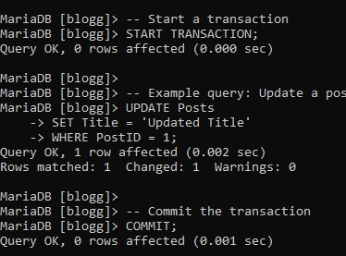

**Fig 5.1** Concurrency Control

Recovery Mechanism

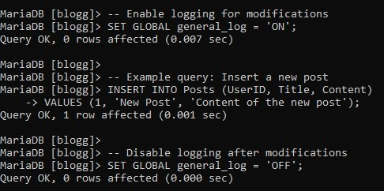

The transaction recovery mechanism with logging typically works:

Logging Operations: Before performing any modification operation (such as inserting, updating, or deleting data), the database management system logs the details of the operation into a log file. This log file is usually stored separately from the main database file to ensure durability in case of a system failure.

Transaction Commit: After the operation has been successfully logged in, the transaction is committed, and the changes are applied to the current database.

System Failure: In the event of a system failure (such as a power outage or hardware failure) before the changes are written to the database file, the database might be left in an inconsistent state. However, because the operations were logged before committing, the log file retains a record of the modifications that were intended to be applied.

Database Recovery: When the system restarts after a failure, the database management system checks the log file to determine if any transactions were left incomplete due to the failure. It replays the logged operations from the log file and applies them to the database, bringing it back to a consistent state.

Transaction Rollback: If a transaction were in progress at the time of the failure and could not be completed, the database management system can roll back the transaction by undoing the logged operations associated with that transaction. This ensures that the database remains consistent and does not include any partially applied changes.

Concurrency Control with Transactions

We will update a post title within a transaction.

Recovery Mechanism with Logging: Before performing the update operation, we will enable logging for modifications, and after that, we will disable logging.

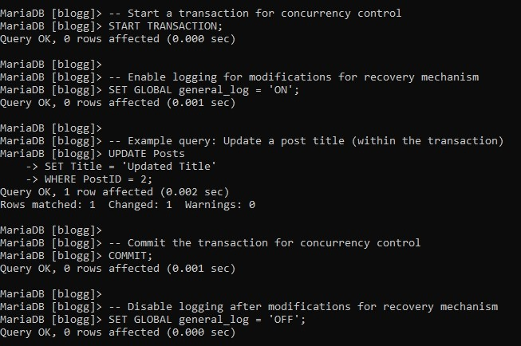

The transaction ensures that the update operation on the post title is executed atomically, ensuring data consistency, and preventing conflicts with concurrent operations. At the same time, logging ensures that even if a system failure occurs after the update operation but before it is committed, the operation details are recorded in the log file. This enables the recovery mechanism to replay the logged operation during system recovery, maintaining data integrity.

**CHAPTER 6**

CODE FOR THE PROJECT

Index.php page:

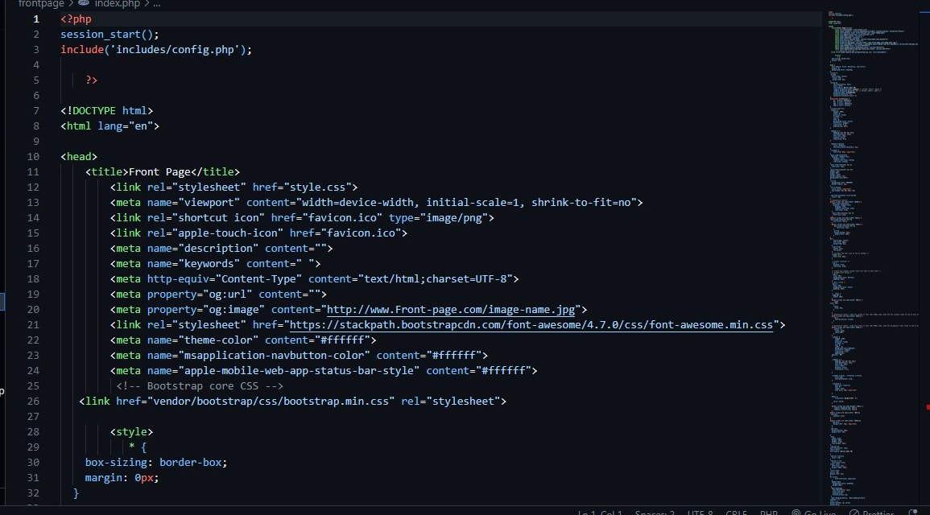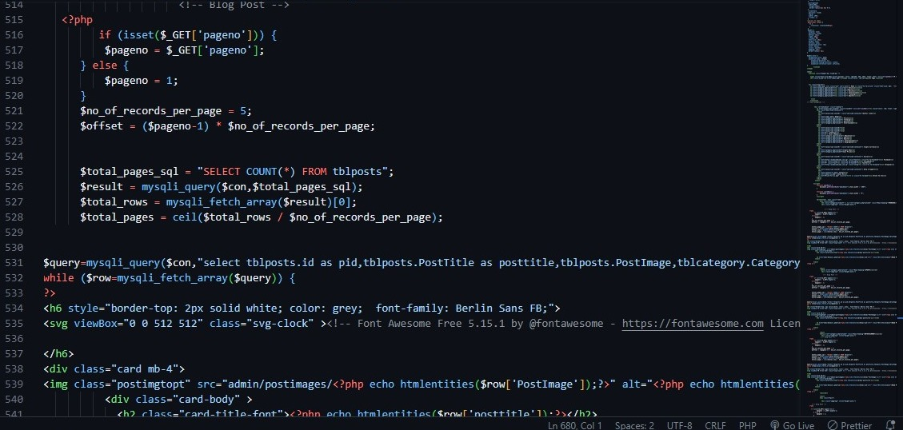

Category Section:

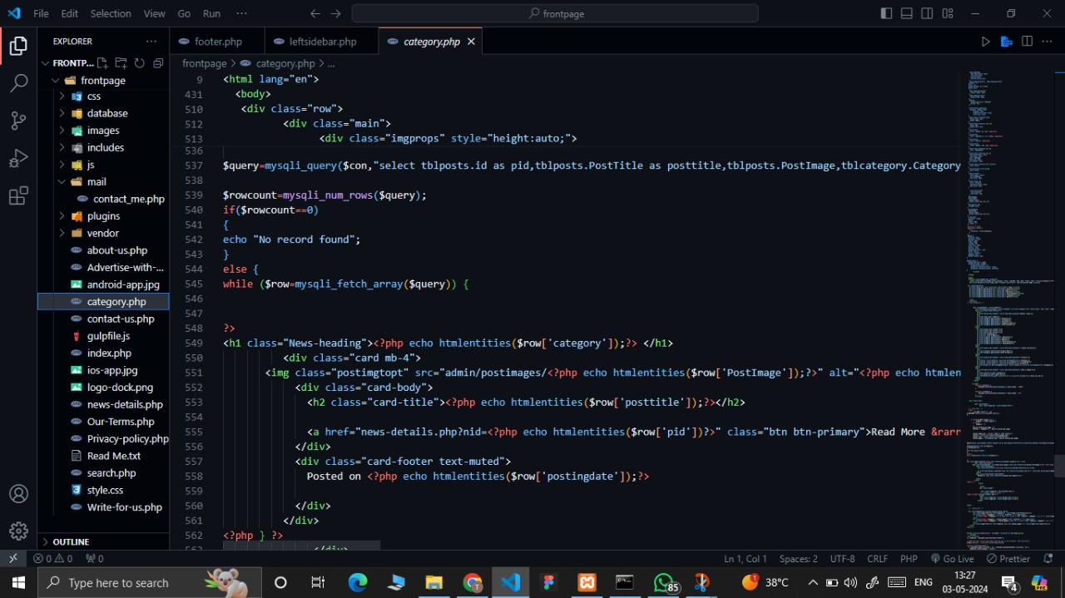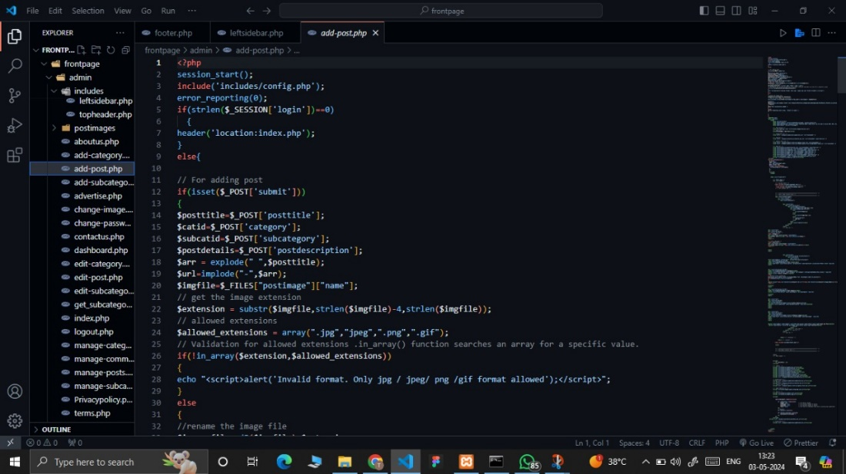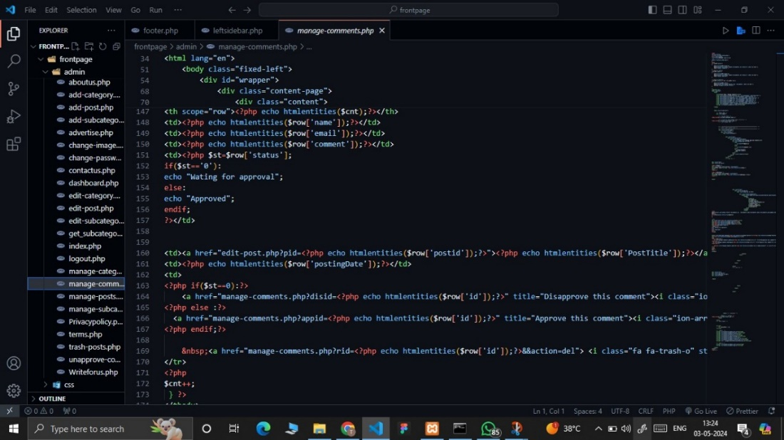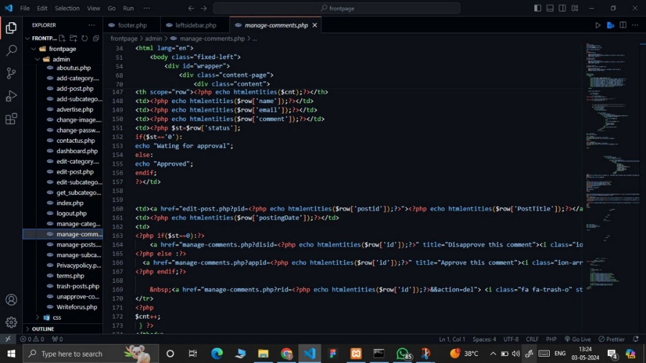

CSS File:

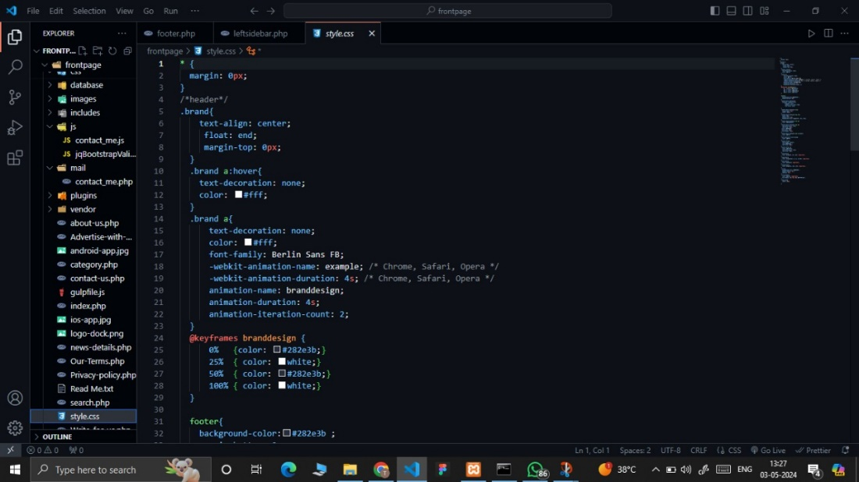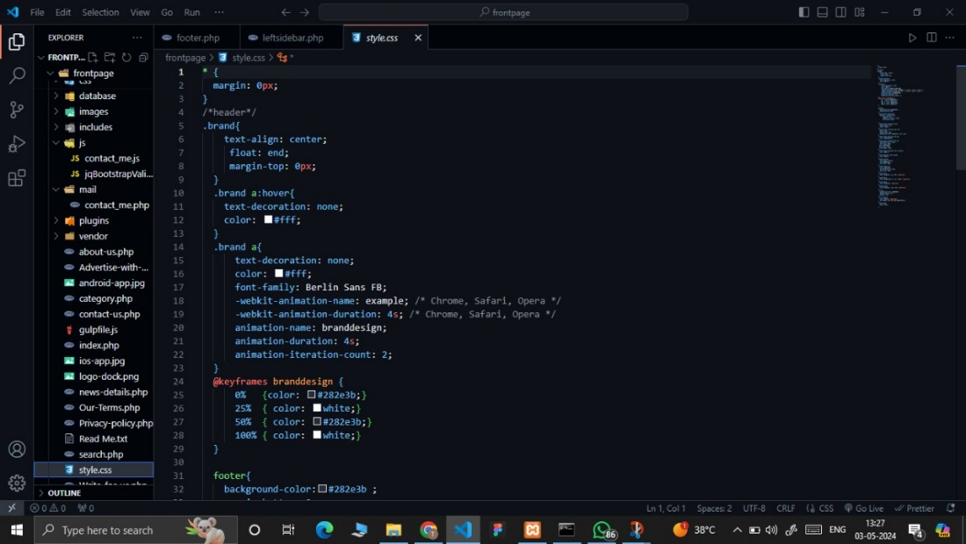

Javascript File:

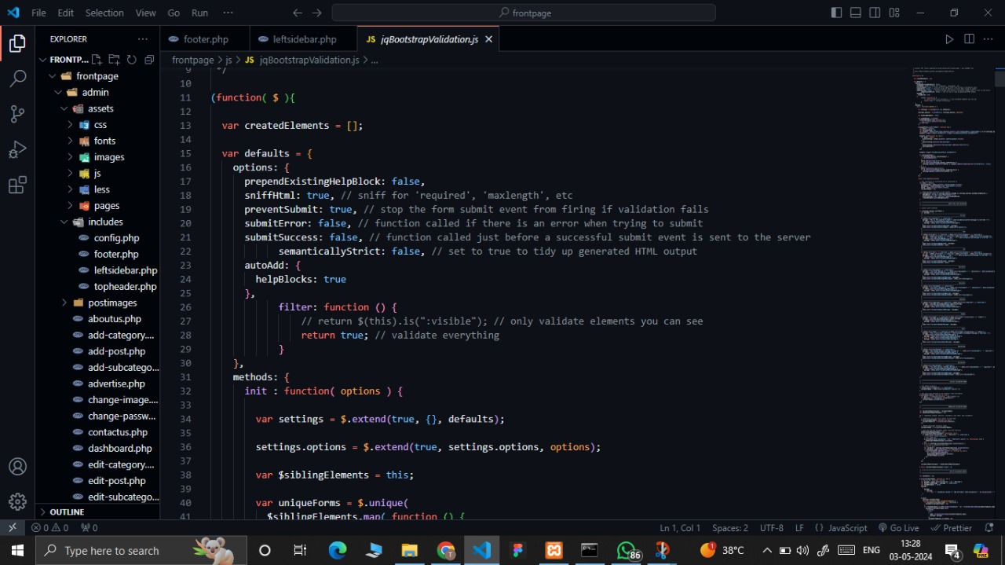

Admin Sections:

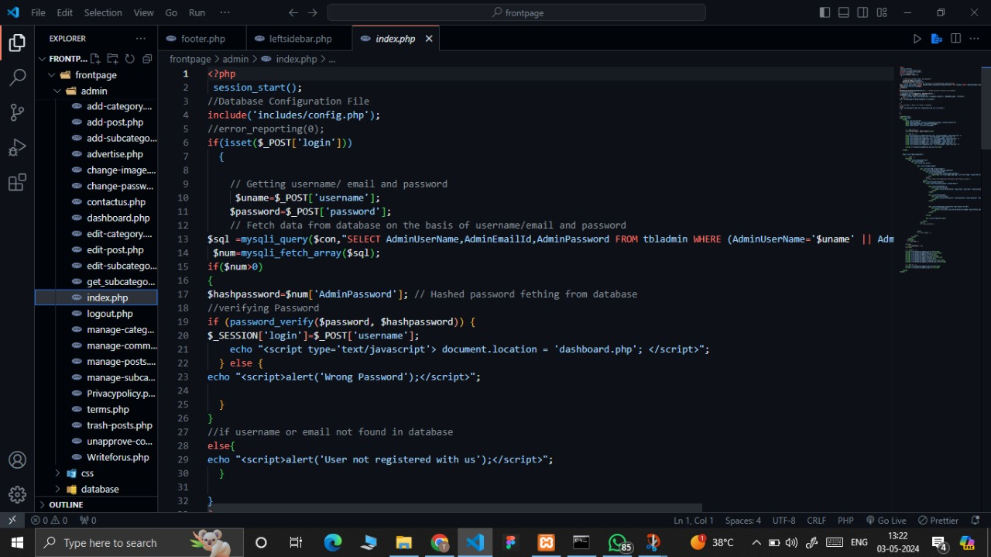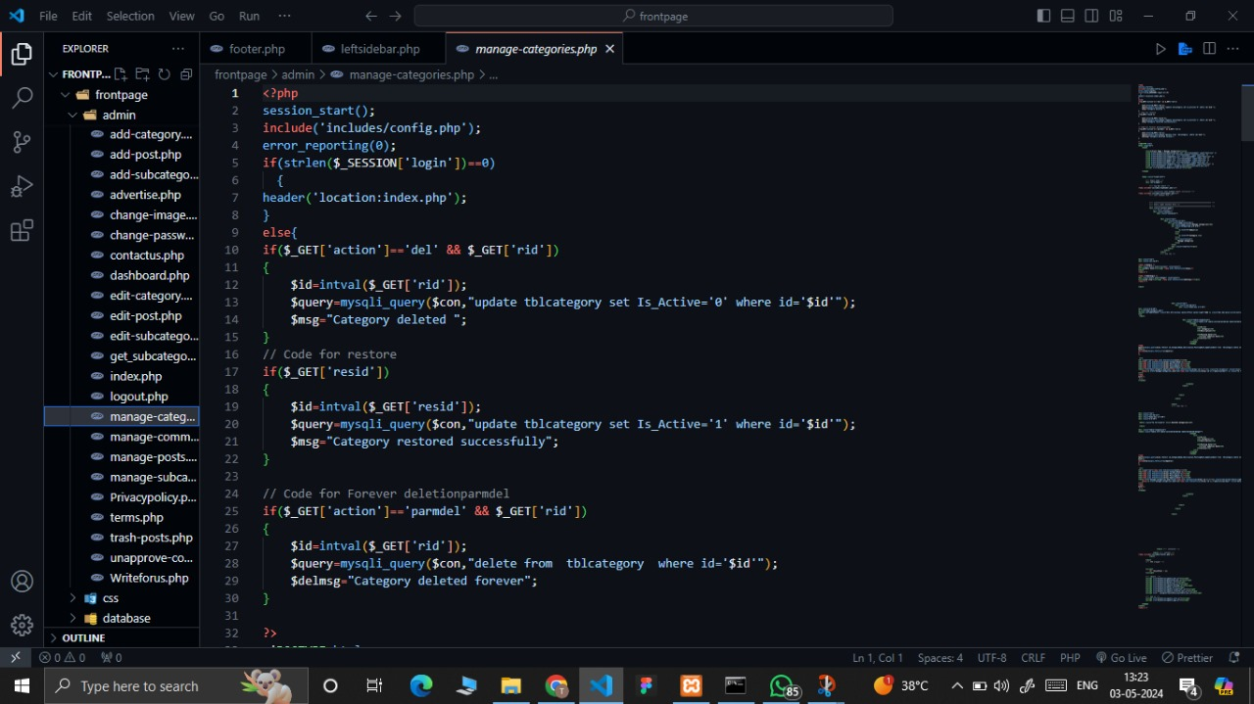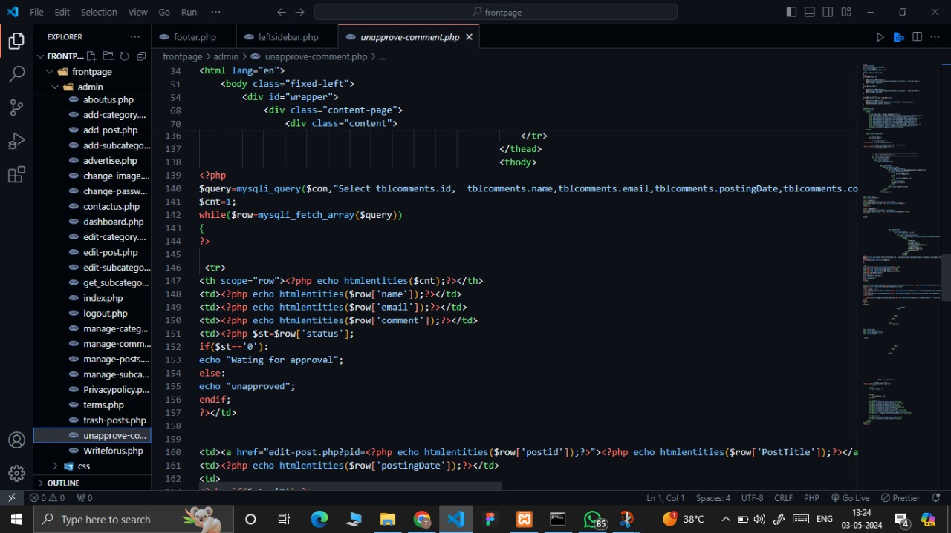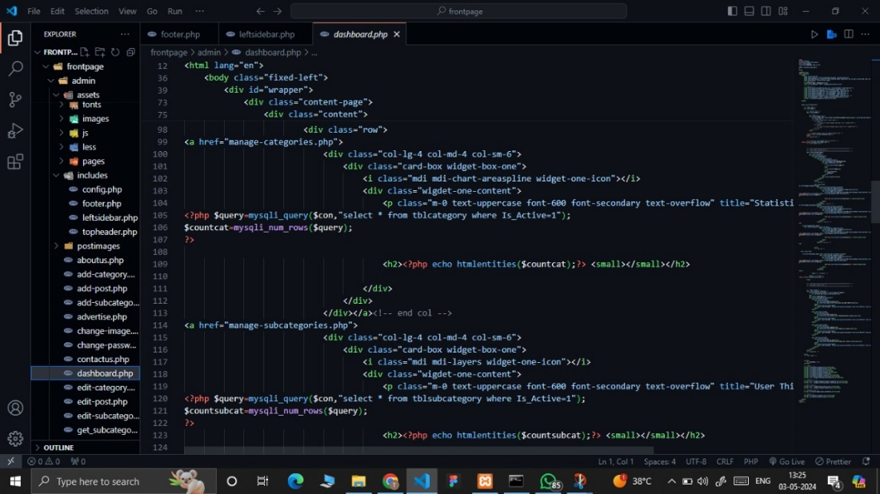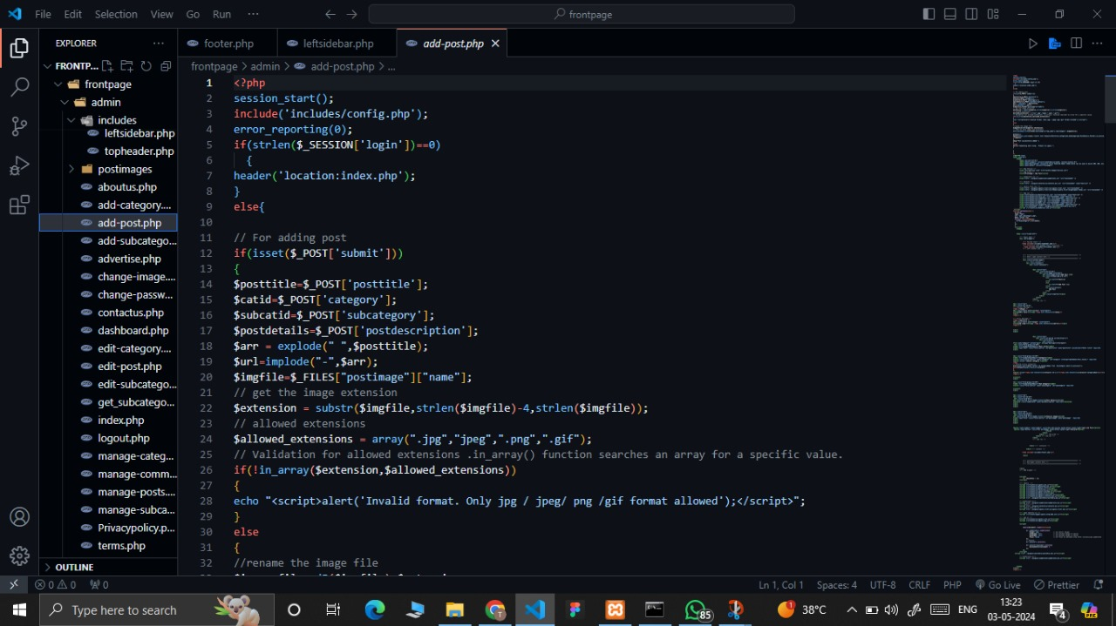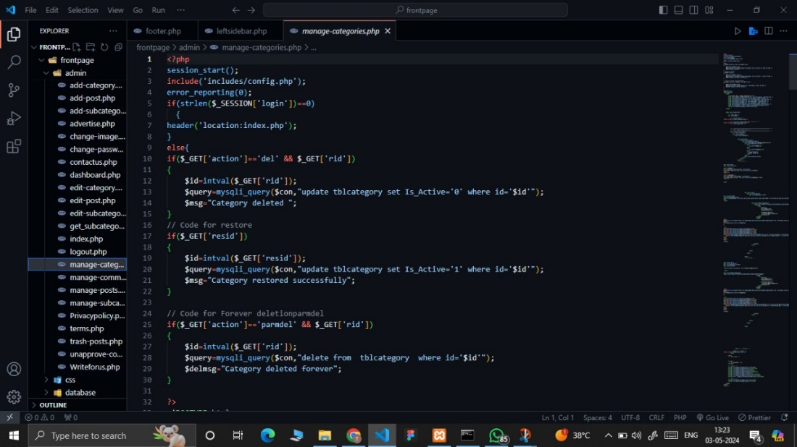

**CHAPTER 7**

Result and Discussion

Front Page:

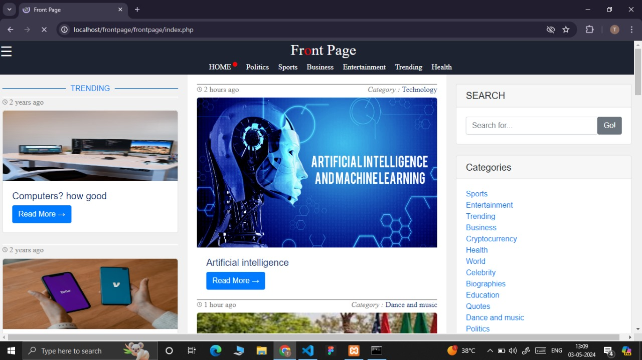

Live Cryptocurrency:

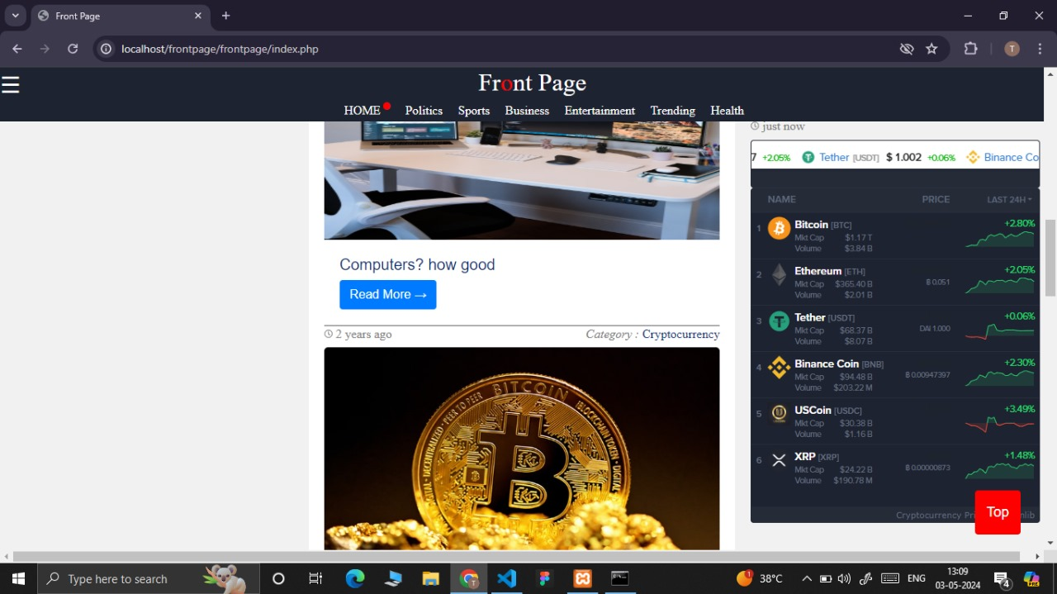

Translation Tool:

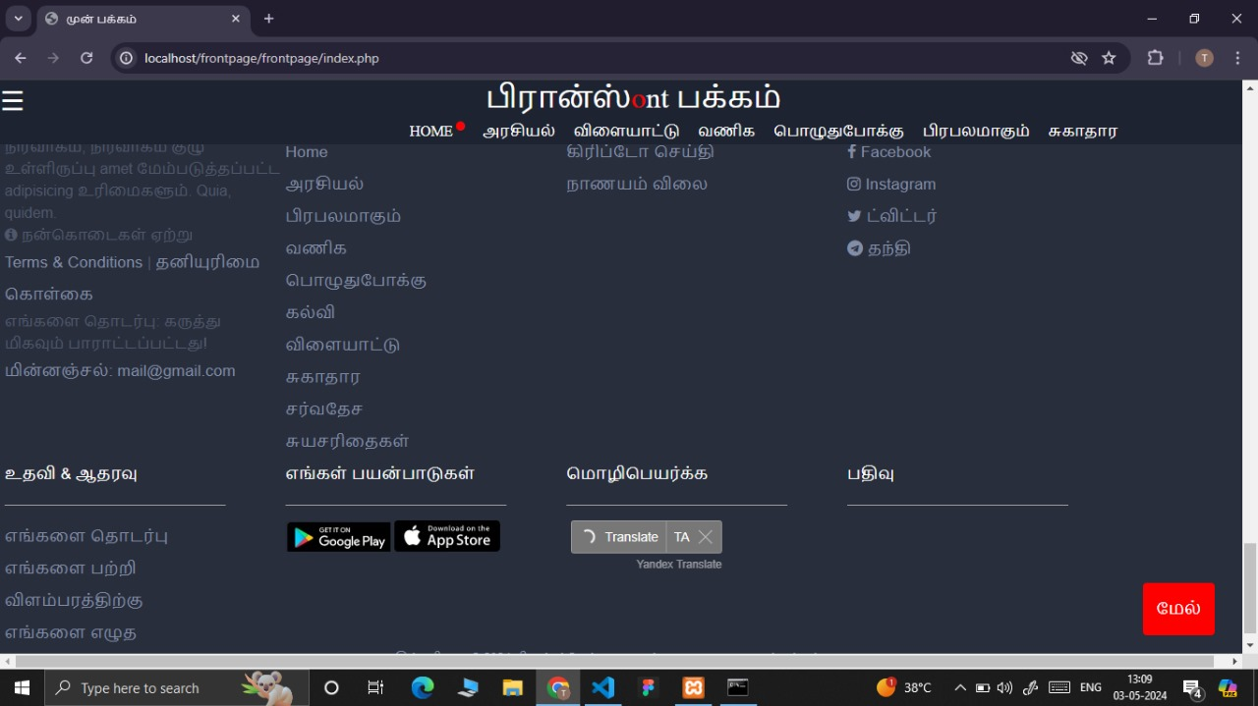

Blog Posts:

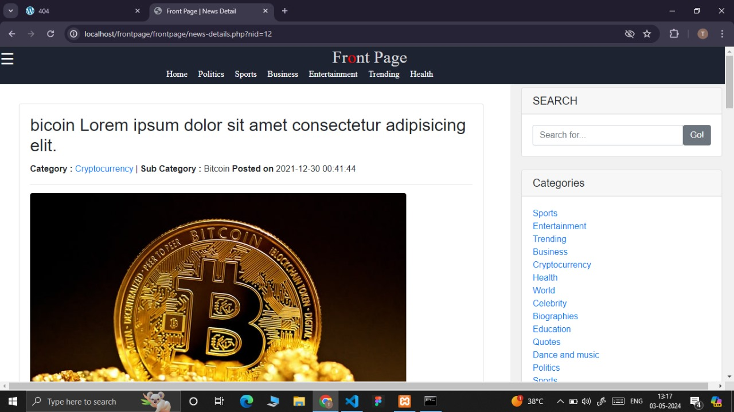

Side Navbar with Categories:

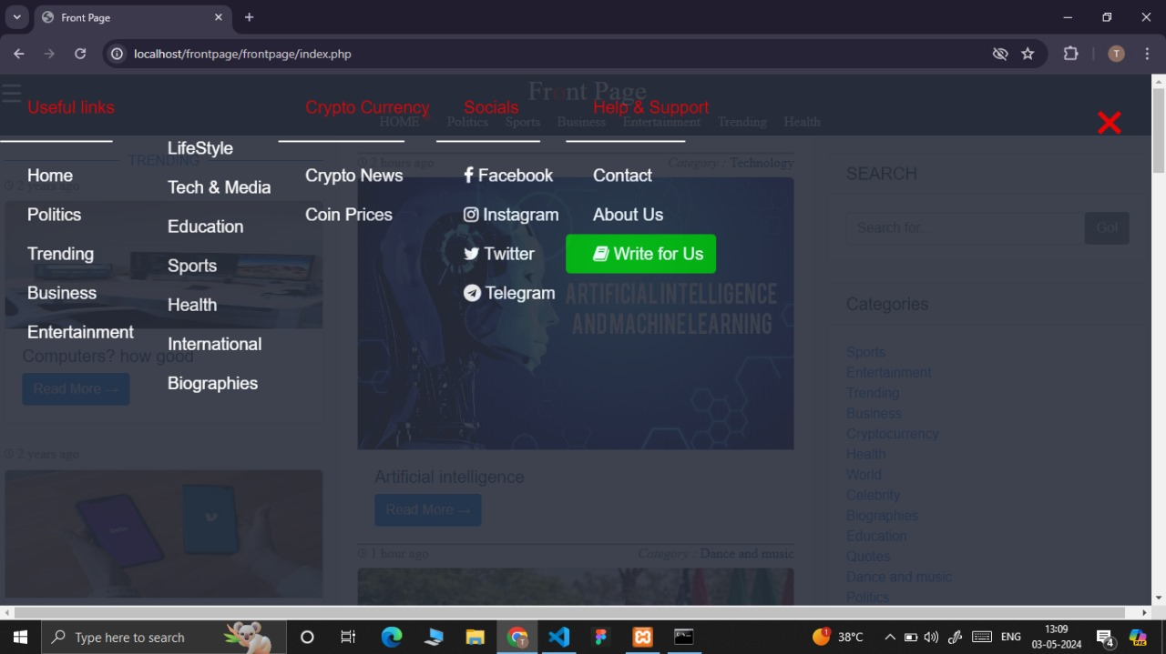

Write for Us Page:



Admin Login Page:

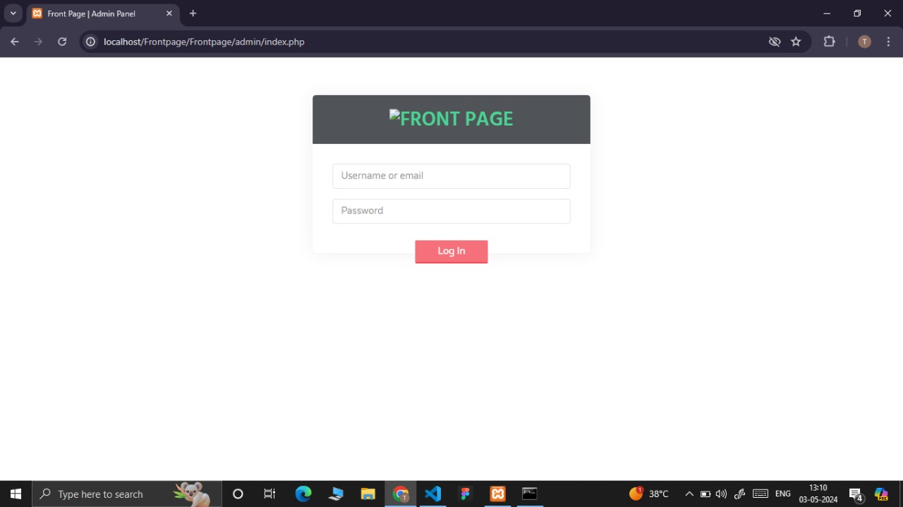

Dashboard for Admin Panel:

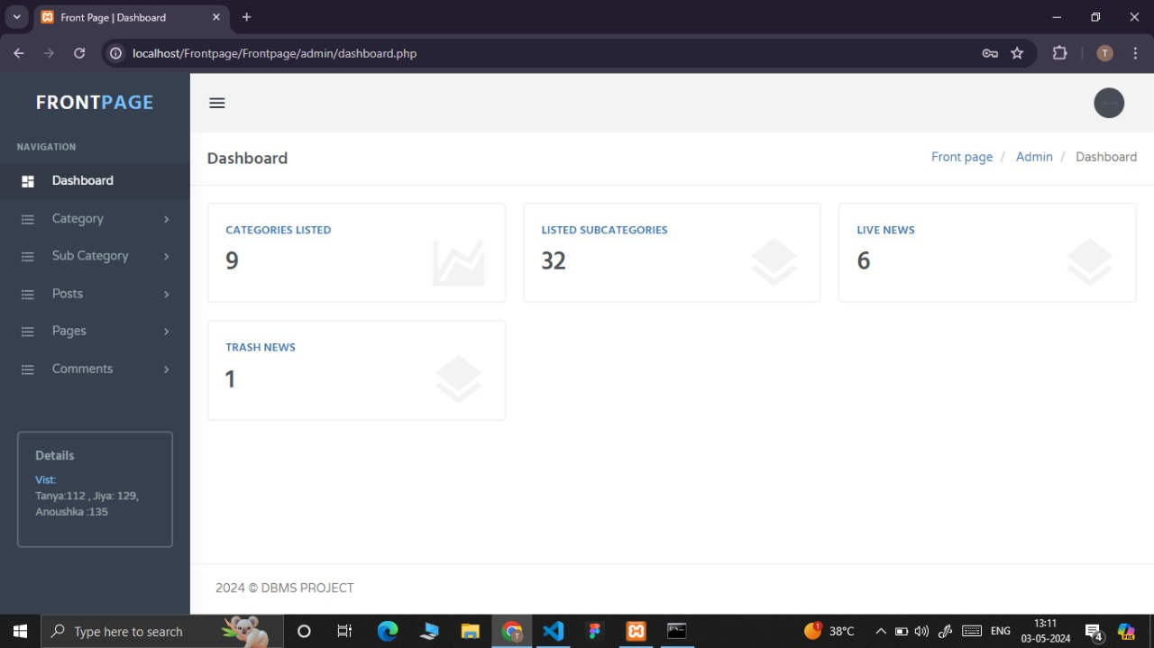

Add Category:

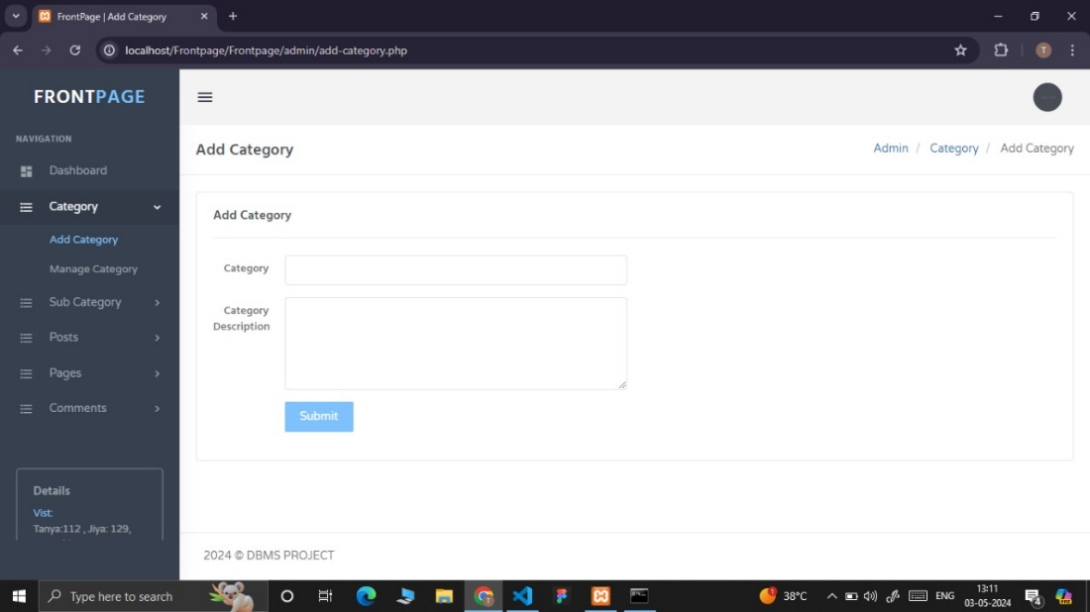

Add Posts Section:

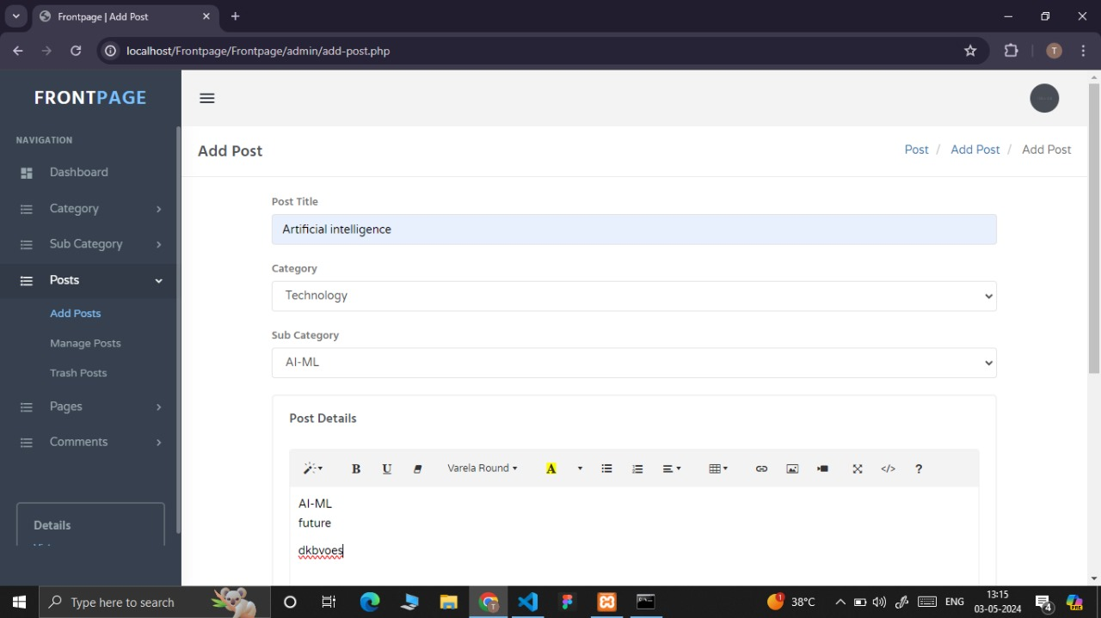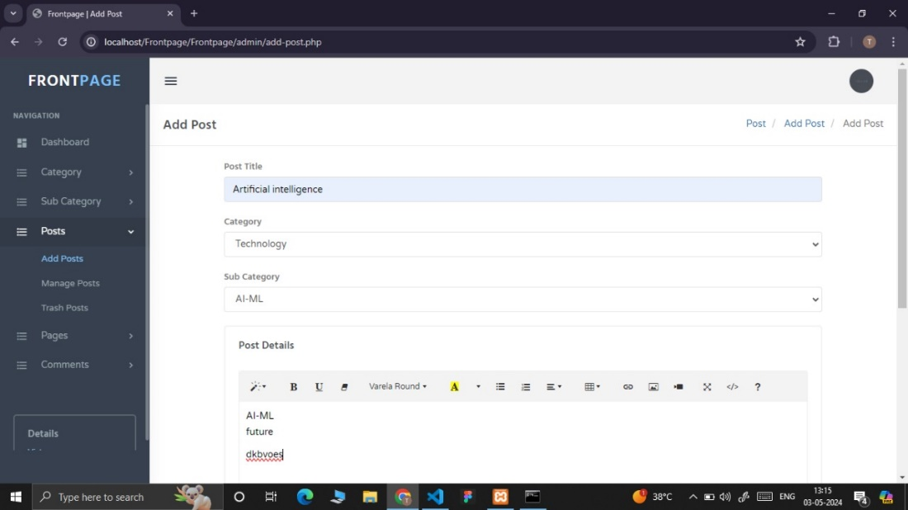

Pending and Approved Comment Section:

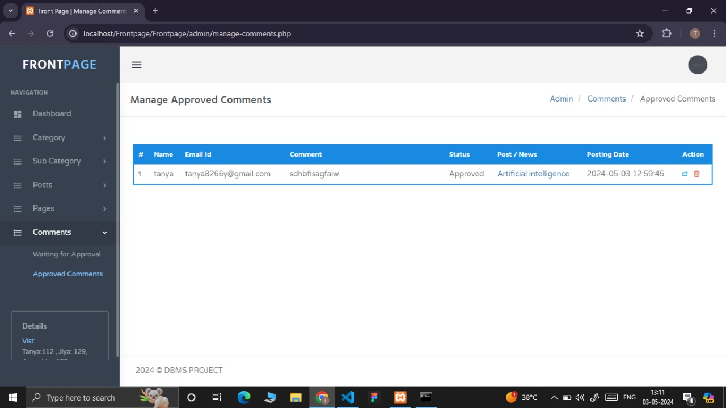

**CHAPTER 8**

ONLINE CERTIFICATION

**Name: Tanya Yadav  
Register Number: RA2211031010112**



**Name: Jiya Gayawer**

**Register Number: RA2211031010129**



**Name: Anoushka Shrivastava**

**Register Number: RA2211031010135**

